**Data Analysis**

* The human resource data was obtained from Kaggle website.
* The data was clean and did not require any cleaning.
* Used SQL to write queries which provide the needed data.
* Used power BI for visualization

**SQL Queries**

--1. Sex distribution in the organization

Select Sex, count(Sex) as No_Of_Employees from hr

where EmploymentStatus = 'active'

group by Sex



--2. Marital status distribution in the organization

Select MaritalDesc, count(MaritalDesc) as No_Of_Employees from hr

where EmploymentStatus = 'active'

group by MaritalDesc

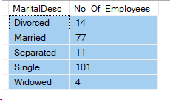

--3. Ethnicity distribution of employees

Select RaceDesc, count(RaceDesc) as No_Of_Employees from hr

where EmploymentStatus = 'active'

group by RaceDesc

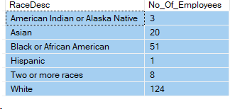

--4. citizenship distribution of employees

Select CitizenDesc, count(CitizenDesc) as No_Of_Employees from hr

where EmploymentStatus = 'active'

group by CitizenDesc

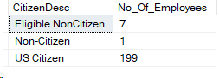

--5. Termination distrbution per department

Select Department, count(TermReason) as Terminated_Cases from hr

where DateofTermination is not null

group by Department

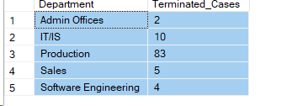

--6. Performance Score distribution

Select PerformanceScore, count(PerformanceScore) as No_Of_Employees from hr

where DateofTermination is null

group by PerformanceScore

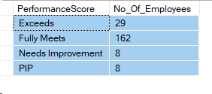

--7. Total number of Employees terminated

select count(DateofTermination) as No_Terminated_Employees from hr

where DateofTermination is not null



--8. Reason for termination distribution

Select TermReason, count(TermReason) as No_Terminated_Employees from hr

where DateofTermination is not null

group by TermReason

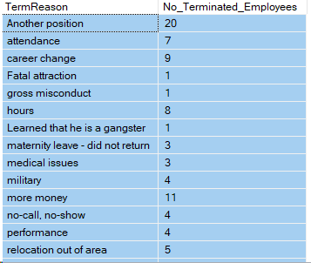

--9. Termination distrbution per gender

Select Sex, count(TermReason) as No_Of_Employees from hr

group by Sex

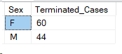

--10. Department with highest employee turnover

Select top 1 Department, count(TermReason) as No_Of_Employees from hr

group by Department

order by No_Of_Employees desc

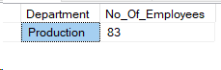

--11. Distribution of Recruitment source

Select RecruitmentSource, count(RecruitmentSource) as No_Of_Employees from hr

group by RecruitmentSource

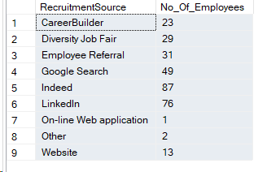

--12. No of employees per departments

Select Department, count(Department) as No_Of_Employees from hr

where EmploymentStatus = 'active'

group by Department

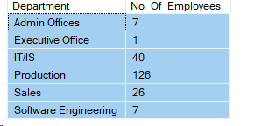

--13. No of managers

select count(distinct managerID) Count_Of_Managers from hr

where EmploymentStatus = 'active'



--14. No of Active Employees

select count(EmploymentStatus) Total_Active_Employees from hr

where EmploymentStatus = 'active'



--15. Avg Employee satifaction

select avg(EmpSatisfaction) Avg_Employees_Satisfaction from hr

